The Japan Foundation Touring Film Programme 2023
Always Evolving: Japanese Cinema Then, Now, and for the Future
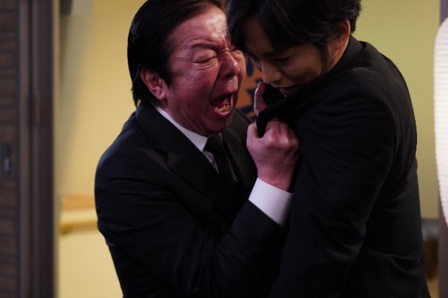 |  | Intolerance  空白  2021, 107 min, English Subtitles  Director: YOSHIDA Keisuke  Cast: FURUTA Arata, MATSUZAKA Tori, TERAJIMA Shinobu
© 2021 “Intolerance” Film Partners  Screening information:  Mon 13 Feb Thu 16 Feb Sun 19 Feb Tue 21 Feb Sun 26 Feb Mon 27 Feb Under the Open Sky Ito The Million Ryo Pot Goodbye Cruel World Intolerance Angry Son 5.30pm 5.50pm 1.15pm 8.20pm 3.30pm 6.00pm  Dates & Venues: 3 – 12 February Institute of Contemporary Arts (ICA), London 3 – 8 February Aberystwyth Arts Centre, Aberystwyth 3 February – 31 March Firstsite, Colchester 4 February – 25 March Phoenix, Leicester 5 – 28 February Showroom Cinema, Sheffield 5 – 28 February Watershed, Bristol 6 February – 28 March Tyneside Cinema, Newcastle 10 – 16 February CHAPTER, Cardiff 10 February – 16 March Brewery Arts Cinema, Kendal 13 – 27 February HOME, Manchester 16 February – 9 March Plymouth Arts Cinema, Plymouth 22 February – 7 March Depot, Lewes 24 February – 18 March QUAD, Derby 25 February – 26 March Queen’s Film Theatre, Belfast 27 February – 20 March City Screen Picturehouse, York 1 – 29 March Exeter Phoenix, Exeter 2 – 30 March Cameo Picturehouse, Edinburgh 6 – 27 March Cinema City Picturehouse, Norwich 10 – 15 March Warwick Arts Centre, Coventry 10 – 16 March Midlands Arts Centre, Birmingham 11 – 29 March Dundee Contemporary Arts, Dundee 15 – 28 March Storyhouse, Chester 18 – 19 March Howard Theatre, Downing College, Cambridge 18 – 23 March Broadway, Nottingham  6.00pm  1.30pm  4.10pm  6.20pm  2.40pm  4.45pm  2.30pm  4.45pm  Major Supporter  Sponsors in Kind  Cultural Partners |  | <Warning! This text contains some spoilers>  In a quiet port town, members of a local community are brought together following the shocking death of school student SOEDA Kanon (ITO Aoi). The victim’s father, a cantankerous fisherman named Mitsuru (FURUTA Arata), antagonises the young grocery store owner who had chased her from the premises into traffic. But AOYAGI Naoto (MATSUZAKA Tori), already haunted by accusations of sexual misconduct from a prior incident, internalises his grief and attempts to go on with his life. As sensationalist media coverage fuels reactive and persecutory behaviour, the victims’ traumas are exacerbated – complicating their journeys towards healing and redemption.  Intolerance is a powerful social drama from Japan Foundation Touring Film Programme (JFTFP) regular YOSHIDA Keisuke. The writer-director (who, interestingly enough, began his career as a lighting technician on Tetsuo: The Iron Man director TSUKAMOTO Shinya’s 1998 noir Bullet Ballet) has straddled dark comedy (Thicker Than Water, 2018) and brutal violence (Himeanole, 2016) with success in the past — and he was honoured with a Director in Focus spot at the Tokyo International Film Festival (TIFF) in 2021. But it is arguably his focus on the complexity of human emotions and relationships that best exemplifies his auteurist signature. Intolerance, built around intense and captivating central performances from FURUTA Arata (13 Assassins) and MATSUZAKA Tori (The Blood of Wolves), and partly based on the director’s own experience of losing his best friend and coming to terms with that loss, captures this humanist knack brilliantly.  The film immediately feels like a progression of the emotional concerns of a previous YOSHIDA film. Boxing drama Blue (which received its Japanese premiere only five months prior to Intolerance) was a highlight of the JFTFP’s 2022 programme, which focused on ‘Dark Minds’ in Japanese cinema. And whereas Blue followed an ensemble of flawed athletes who pursue boxing careers for different and often misguided reasons, so too does Intolerance see the unique traits and needs of its troubled characters mirrored and reflected by their opposites on-screen.  Mitsuru, for example, doggedly pursues the theory that his daughter was bullied — but is unbothered by his own aggressive behaviour towards everyone he encounters. His estrangement and alienation of others, whose love and support might have tempered his toxic mentality, is  P.T.O  mirrored in the unwavering support that Naoto receives from a female co-worker, KUSAKABE Asako (TERAJIMA Shinobu). Naoto, on the other hand, harbours regret for the strained relationship he held with his own father, echoing the exchange glimpsed between Mitsuru and his daughter in the film’s opening. Naoto’s stoic manifestation of his grief, meanwhile, contrasts with that of the motorist involved in Kanon’s fatal accident — who is unable to contain her remorse. When both characters attempt to act on their emotions later on, the outcomes are polarised.  If these characters were better able to process their experiences and understandings of the tragedy through positive communication and interaction with one another, then salvation might be achievable. It’s an idea underlined in YOSHIDA’s disorderly mise-en-scène, which dwells on mismatched crates in jumbled storerooms, the hodgepodge of supermarket floors, and the chaotic assembly of text and graphics on televised news reports. A flyer asking for “ocean clean-up volunteers”, meanwhile, further underlines the urgent necessity for a kind of communal emotional re-organisation.  Elsewhere, the quivering camerawork provided by cinematographer SHIDA Takayuki (Nightmare Detective; Himeanole) augments the feeling of uncertainty and instability — while also adding a sense of realism conducive to the naturalistic performances. It is arguably the film’s sun-bleached colour scheme, though, that offers the best visual manifestation of the themes of loss and grief.  Just as the characters of Blue had been combatants of the boxing ring’s blue corner (traditionally signifying the unfulfilled challenger, as opposed to the fulfilled champion of the red corner), Intolerance is characterised by its insistent use of blue, white and grey — evoking the cold, limbo-like feeling of being held in a clinical space such as a hospital. The red-draped restaurant where Mitsuru and Naoto exchange an intense dialogue, and the bright pink apron worn by Asako, then, stand out as significant— while the film’s conclusion offers a powerful visual catharsis that offers a fleeting departure from this otherwise resolute limitation of colour.  James Balmont  Freelance arts and culture writer based in London  Copyright belongs to the Japan Foundation. You may not copy, reproduce, distribute, modify, or distribute any part in any form without permission.

