HOME is a trading name of Greater Manchester Arts Ltd
a company limited by guarantee, registered in England and Wales No: 1681278

Registered office 2 Tony Wilson Place Manchester M15 4FN. Charity No: 514719
HOME is pleased to present three new exhibitions in our Gallery from Sat 18 Feb – Sun 4 Jun
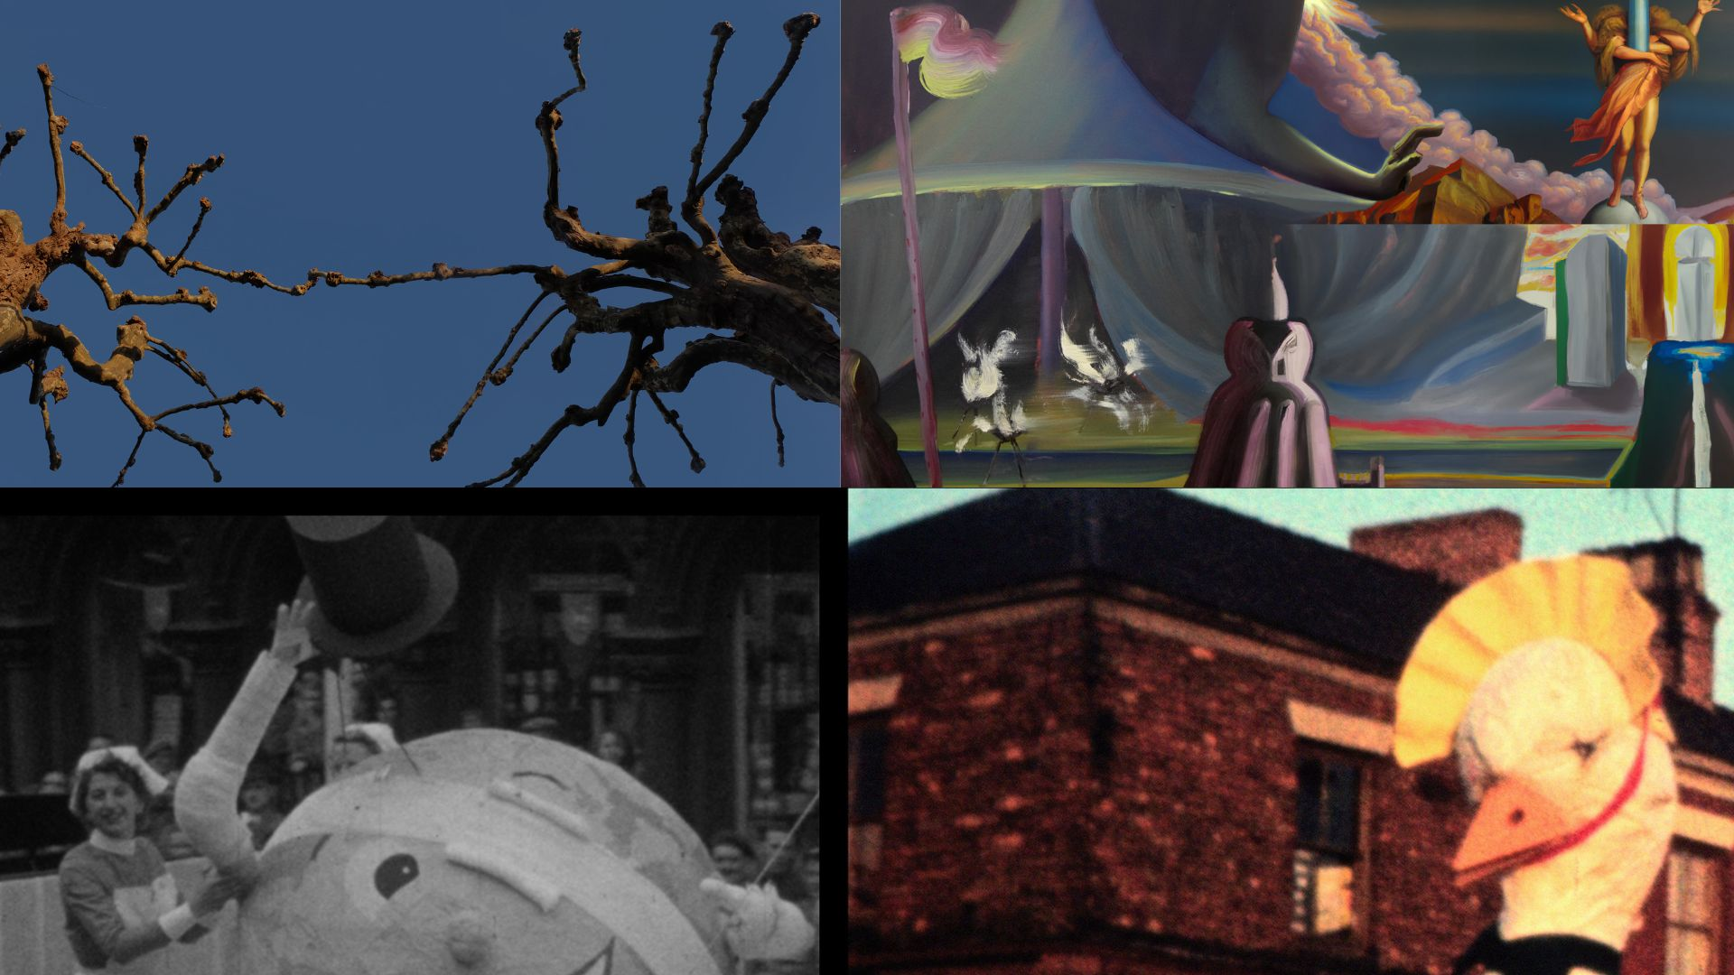
HOME Gallery
Sat 18 Feb – Sun 4 Jun
Preview Fri 17 Feb 18:00 – 21:00
Featured Exhibitions:
- Natural Interaction, an exhibition by artist Nick Jordan
- Painting, An Unending, a show of new work by Parham Ghalamdar
- Is there anybody there?, a show by artist filmmaker Chris Paul Daniels
HOME is delighted to present three exhibitions in our Gallery this spring, featuring solo work from three artists, Nick Jordan, Parham Ghalamdar and Chris Paul Daniels. Featuring works that span film, photography, painting and sculpture, these three solo exhibitions offer an exciting opportunity to see the work of three artists at critical stages in their careers.

Please see details of each exhibition below:
Natural Interaction, a solo exhibition by artist Nick Jordan. Featuring new films, prints, photographs, painting and sculptural works, the exhibition explores the interdependencies between social and ecological healthcare or wellbeing.
Drawing upon the artist’s recent collaborations with ecologists, materials scientists, and healthcare professionals involved in medical genetics, the work interconnects the lived experience of rare health conditions with the reciprocal behaviours and symbiotic systems found in nature.

A new film trilogy (Rare Frequencies, Genetic Sequences and The Entangled Forest) captures the unique features of ecologically diverse habitats which sustain many rare or endangered species, playing a vital role in mitigating the impacts of climate change. Combined with audio conversations that reflect upon the importance of science and the lessons we can learn from nature, Jordan’s hybrid documentaries explore diverse landscapes and ecosystems, including restored peatlands, networks of mycelium, botanical gardens, urban woodlands and ancient forests; threading together themes of community and mutuality, resilience and renewal.

Rare Frequencies draws upon conversations with people impacted by rare diseases, as well as health practitioners involved in medical genetics and counselling. Jordan combines the discussions with footage he filmed at a restored peatland habitat on the edge of Manchester, which now hosts many rare species of wildlife.

Genetic Sequences continues the conversations with medical geneticists and psychologists, filmed in Vienna for the European Society of Human Genetics. The discussions reflect on interrelated issues such as global healthcare inequalities, access to vaccines, trust in science and hopes for the future. Shot in a single weekend, the film captures an urban topography, from public parks and city streets to the global plant collection of the University of Vienna’s Botanical Garden.

Completing Jordan’s trilogy of new films is The Entangled Forest, which explores the reciprocal, shared behaviours that exist between trees and fungi. Filmed from the heat of late summer to the frozen depths of winter, in diverse woodland habitats, the documentary features the voice of ecologist Suzanne Simard, and her ground-breaking research into the ‘biological neural network’ of forest ecosystems.

Each of the films feature an atmospheric and textural soundtrack score, recorded with traditional folk instruments, woodwind and analogue synths, composed by Otis Jordan (Rare Frequencies and Genetic Sequences) and Otis Jordan and Lord Mongo (The Entangled Forest).

Creating dialogue and interconnections with the films are a series of new works by the artist, including mushroom spore prints presented as a family tree, archival botanical drawings, a greenhouse, and a living micro habitat of native bog plants.

Painting, An Unending, a solo show of new work by Parham Ghalamdar, his largest institutional exhibition to date. His work draws on traditions of Persian and Western art, graffiti, internet and digital culture. Elements abstracted from a range of personal and cultural references such as Piero de la Francesca’s fresco Dream of Constantine and objects from American cowboy cartoons or sci-fi refences consumed during his childhood in Iran, are painted against bleak landscapes creating often absurdly humorous epic scenes. Eschewing narrative, he approaches his work as a performer warming up their vocal cords, shape shifting colour with texture, surface quality and composition to infuse a dreamlike, surreal sensibility.
The tent featured in Francesca’s 15 Cent. fresco Dream of Constantine is used as a trope throughout Painting, An Unending. Located in a church in Arezzo, Italy, the fresco depicts the night before the Battle of Milvern Bridge, fought between the Roman Emperors Constantine and Maxentius. Historicised as the event that marked the death of paganism and the birth of Christianity as the dominant religion for the empire and Europe, the work symbolises a significant turning point in social, cultural and political consciousness. As such, for Ghalamdar, the work signifies a moment of pause, an ‘in between state’; flickering between past and future; charged ambiguity or promise. Autobiographically, the work resonates as a state of transition, migration and shelter.

For Painting, An Unending, he has used an artificial intelligence tool that creates realistic images from text descriptions, as an extension of his sketchbook. Testing the AI generator’s capabilities in rendering the aesthetics of the classic masters’ into an image, he prompts it with social scenes or situations that due to his political beliefs or sexuality would be impossible in his homeland. The results appear surprising and random. Incorporating them into his work, he repaints and repeats the process endlessly. The work jumps from one epoch or socio/political order to another within the same canvas, exploring notions of identity politics, migration, freedom of movement, boarders, community and belonging.

The repetition and production of his work can be seen as a liberating process of catharsis; reconciliation or reckoning with his past, coming of age in an authoritarian regime. In a country where imported western culture was readily consumed, yet laws on the production of culture in Iran are consistently ambiguous, redefined or banned, Ghalamdar pushes the limitations of the medium of painting through AI image synthesis, navigating the tensions and traversing between self-expression and authorship; authenticity and censorship.

Is there anybody there? a solo show by artist filmmaker, Chris Paul Daniels. His work responds to place, merging communal memory with experimental observation and fictional narration. For this exhibition, Daniels has sourced 70 different films from the North West Film Archive at Manchester Metropolitan University, editing them together to create a monumental study of cultural traditions, procession and ceremony. Guided by the unseen presence of a disembodied voice, the artist’s fictional script and original musical score composed by Graham Massey (808 State, Massonix), reanimate past archival footage whilst addressing how film can be authored and mediated.

Original footage from across the North West has been shot by enthusiasts in their homes, on the street, by local film societies or professional productions, on media ranging from super 8 or 16mm film to analogue and digital video. The films feature elaborate costumes of popular and imaginary figures, people performing puppetry or magic tricks, competitive weightlifting, high wire acrobatics, community arts performances, or parades such as Whit walks, pageants and pride marches from as early as 1901 to the present day.

Edited together to create a continuous flowing choreography, Is there anybody there? explores notions of individual and collective archival memory, how it is created, by whom, (posing questions around who had the means to access the camera) and consequently whose stories, identities or cultures may be missing.
Daniels uses the archival footage as a malleable material to be sculpted, fragmented, collapsing and disrupting the chronology of time, dancing from one era or location to another. The composition of image, narrative and score are developed intuitively and in dialogue, both informing the other as the narrative evolves. The single voice narration meanders from benignly descriptive, speculative, teasing the viewer with visual jokes, to declaratory or conveying allusions to being summoned, and through the conflation with moving image, the film takes on a sentient presence.

In this film, archival footage normally presented as evidence, becomes mere speculation; a metaphor for the uncanny or past lives. Fascinated by the slippages between what is real and what is not, the artist explores how historical events morph between legend, myth or folklore, or how endlessly performed rituals can become estranged out of time. The precarity of the narrative of history is exposed through fictions told by an unreliable narrator and proposes new stories to make sense of our lives for a parallel present or a projected future

ENDS

Notes to Editors:

For interviews and additional information, please contact Julia White, Head of Communications at HOME, on 0161 212 3463 or email julia.white@homemcr.org

Please see the Main Gallery Spring 2023 webpage here.

Credits and biographies:

Natural Interaction is curated by Clarissa Corfe.

Rare Frequencies produced for the Whitworth Group’s RARE/D podcast series, Manchester Centre for Genomic Medicine, supported by Economic and Social Research Council and EURORDIS Rare Diseases Europe.

Genetic Sequences was commissioned by European Society of Human Genetics, with support from the University of Manchester and Manchester University NHS Foundation Trust.

The Entangled Forest was supported by UK Research & Innovation and The University of Manchester. Commissioned by HOME.

Earth House Hold is made with the cooperation of The Research Foundation for the State University of New York, University at Buffalo, School of Public Health and Health Professions.

Nick Jordan is a multidisciplinary artist whose work explores the interconnections between cultural, social and natural ecologies. The artist’s work has been exhibited widely at international museums and galleries, including Innsbruck International Biennal, Austria; Videonale, Kunstmuseum Bonn, Germany; Musée du Quai Branly, Paris, France; Whitstable Biennale, UK; Centre de Cultura Contemporània, Barcelona, Spain. Jordan’s award-winning films have featured in many international film festivals, including special focus programmes at the London Short Film Festival, UK; Minimalen, Trondheim, Norway; HOME Artist Film Weekender, Manchester, UK. Artist residencies and commissions include Headlands Center for the Arts, San Francisco, USA, The National Trust, UK; The Manchester Museum, UK; Newcastle University, UK / Stasi Archives (Germany; ICA, London, UK; Thackray Museum of Medicine, UK; Art Gene, UK; British Society of Aesthetics, UK; Arts & Heritage, UK. Jordan is the co-author (with Jacob Cartwright) of Alien Invaders: A Guide to Non-native Species of the Britisher Isles (Bookworks), and is the curator of Braziers International Film Festival, UK. Nick Jordan studied Fine Art at Nottingham Trent University (BA) and Manchester Metropolitan University (MA). He is based in Manchester.
www.nickjordan.info @nickjordanart

Painting, An Unending Parham Ghalamdar is curated by Clarissa Corfe. Commissioned by HOME.

Parham Ghalamdar is a painter and has a background as a member of the graffiti collective ELF in Tehran. He studied MA in painting at Manchester School of Art and specialized in oil painting. His recent work examines the relationship between contemporary painting with the past, i.e. Christianity, and the future, i.e. internet and digital culture to negotiate the present.
Ghalamdar has been expanding his painting and drawing practice into the digital realm since the temporary closure of his studio during the national lockdown in 2020. This resulted in 9 thousand frames of animation produced in the past two years. He has recently finished two short animations/films in collaboration with the director Martin Cooper, commissioned by the Oscar-winning artist, animator, filmmaker, Joan Gratz. Ghalamdar is a member of the Workplace Foundation’s Community of Artists. He currently has a solo screening of his animation at Bavan Gallery, Tehran, Iran. Recently solo exhibitions include Fig.1 at Caustic Coastal; A fine Kettle Of Fish at Granada Foundation Galleries HOME, Manchester, and Against the Absurdity Of Life at Maria Behnam-Bakhtiar Gallery, Monte-Carlo, France. Recent group exhibitions include at Rebecca Hossack Gallery, London; London Paint Club, Floorr Magazine; Castlefield Gallery, Manchester; Manchester Art Gallery; Whitworth Art Gallery, Manchester; Beep Painting Biennale, Swansea; Asia Now Art Fair, Paris. In 2022 he undertook as residency at Desire Lines Residency Programme.

Is there anybody there? by Chris Paul Daniels is curated by Clarissa Corfe. Commissioned by HOME. Supported by the North West Film Archive at Manchester Metropolitan University

Chris Paul Daniels graduated from the Royal College of Art in 2010 and lives and works in Manchester. His moving image work has been screened at film festivals and galleries internationally and is included in collections at University of Salford Art Collection, Grundy Art Gallery and Blackpool Council Collection via the Art Fund. He co-founded Unravel, the longest hand painted ﬁlm in Britain which led over a hundred public events across the UK including Tate Britain, BFI Southbank, Turner Contemporary and IKON Gallery and a residency at the Whitney Museum of American Art in New York. Recent works include ‘SAFE’ at HOME, ‘One Square Mile’ for Quays Culture & University of Salford Art Collection (with Sam Meech) ‘Northern Lights’ a co-commission by ICA & The Grundy Art Gallery, ‘The Book of Lies’ for the National Museum of Iceland, and ‘Steinrunnin/Petrified’ commissioned by Curated Place and Einkofi Productions. He is a studio holder at Paradise Works Artist Studios in Salford, and a film programmer for the ‘Cinema Paradiso’ events as part of HOME’s Artist Film Weekender, and also Braziers International Film Festival. He is a Senior Lecturer in Filmmaking at the School of Digital Arts, at Manchester Metropolitan University.

HOME is Manchester’s centre for international contemporary culture. Since opening in May 2015, HOME has welcomed over four million visitors to its two theatres, five cinemas, art gallery, book shop and restaurants. HOME works with international and UK artists to produce extraordinary theatrical experiences, producing an exciting mix of thought-provoking drama, dance, and festivals, with a strong focus on international work, new commissions and talent development.

HOME’s ambition is to push the boundaries of form and technology, to experiment, have fun, take risks and share great new art with the widest possible audience. The patrons of HOME are Danny Boyle, actress Suranne Jones, playwright and poet Jackie Kay CBE, artists Rosa Barba and Phil Collins, filmmaker Asif Kapadia, and actress and author Meera Syal CBE.

www.homemcr.org | @HOME_mcr | Facebook @HOMEmcr

FUNDED BY:
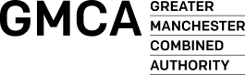

FOUNDING SUPPORTERS:
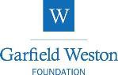
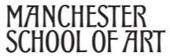
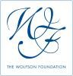

Did you know that HOME is a charity? We need your support to bring the best film, theatre and art to Manchester and inspire the next generation. Get involved at www.homemcr.org/support

